Contents

Website Framework 2

Overview Page 3

Author Page 5

Earthquake Page 7

Weather page 9

Tutorial index page 11

GeoJSON tutorial page 13

Weather fundamentals tutorial page 15

Earthquake fundamentals tutorial page 17

JavaScript techniques tutorial page 19

User created visualisation page #1 21

User created visualisation page #1 – Tutorial Page 23

User created visualisation page #2 25

User created visualisation page #2 – Tutorial Page 27

User created visualisation page #3 29

User created visualisation page #3 – Tutorial Page 31

User created visualisation page #4 33

User created visualisation page #4 – Tutorial Page 35

# Website Framework

Website framework – This is the framework for the website and includes information that is always displayed on every page such as the logo, navigation bar, footer with copyright information, back-to-top button.

**Requirements:**

Responsive layout

Aesthetically attractive

Consistent design/layout

**Selected Design:**

**Mobile:**

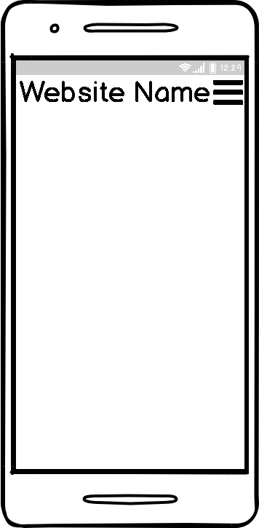

The design is simple and easy to use for all users, it’s consistent with all the other designs, its simple and aesthetically pleasing. The page features a hamburger menu that expands into the menu and helps accessibility as people will instantly know what it is.

**Tablet:**

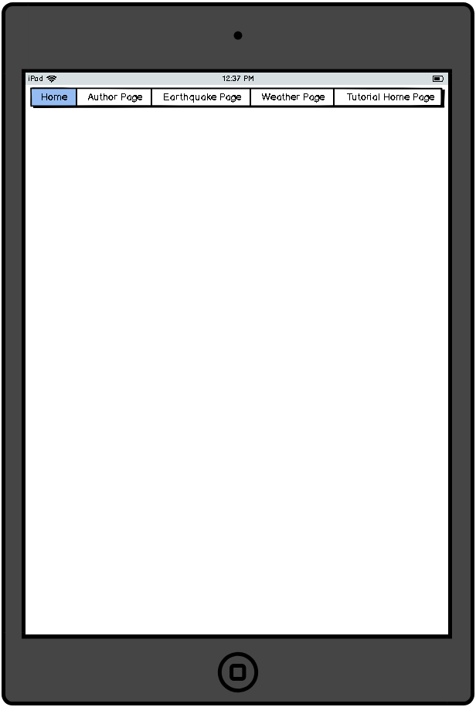

The design is simple and easy to use for all users, it’s consistent with all the other designs, its simple and aesthetically pleasing. Since the screen is bigger there’s no need to hide the menu so a navigation bar is used instead.

**Desktop:**

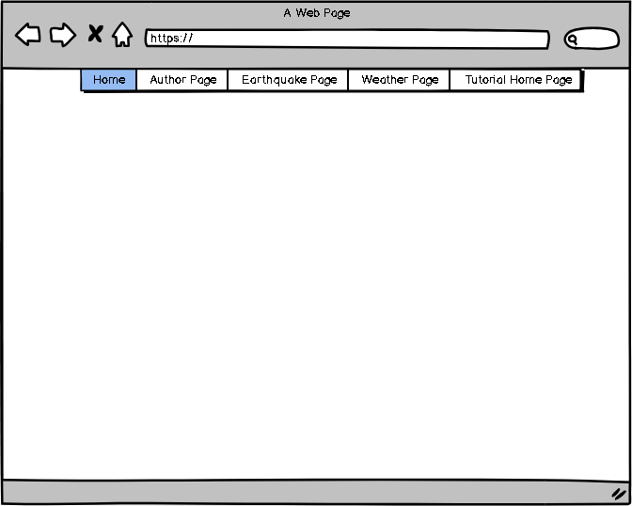

The design is simple and easy to use for all users, it’s consistent with all the other designs, its simple and aesthetically pleasing. Since the screen is bigger there’s no need to hide the menu so a navigation bar is used instead.

**Checklist**

|  |  |
| --- | --- |
| **Requirement** | **Complete** |
| Responsive Layout |  |
| Aesthetically attractive |  |
| Consistent design/layout |  |
| Logo |  |

# Overview Page

The website overview page will function as the website homepage

Explain the purpose and content of the IP3 project, provide a link to the specification in PDF format.

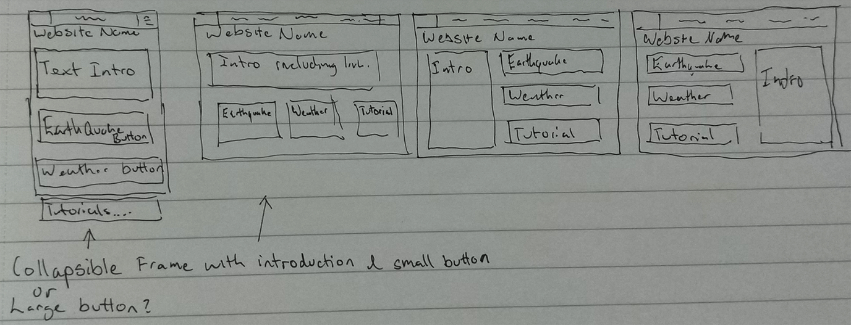

**Requirements:**

Responsive layout

Aesthetically attractive

Consistent design/layout

Explain the purpose and content of the IP3 Project

Include a link to a version of the project specification document in a suitable format (PDF)

**Selected Design:**

**Mobile:**

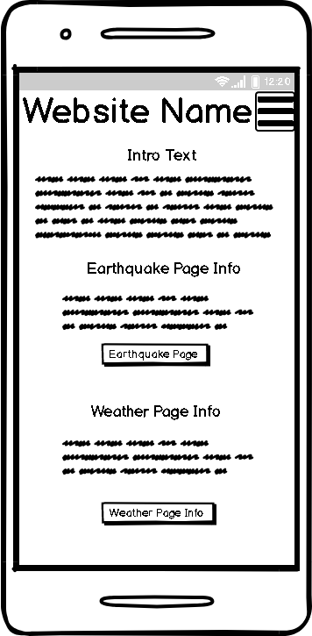

The layout is clean and concise, the page features buttons which will give quick and easy navigational access, the page features basic information about each and every page, this page would extend further down as the mobile does not feature as much horizontal space.

**Tablet:**

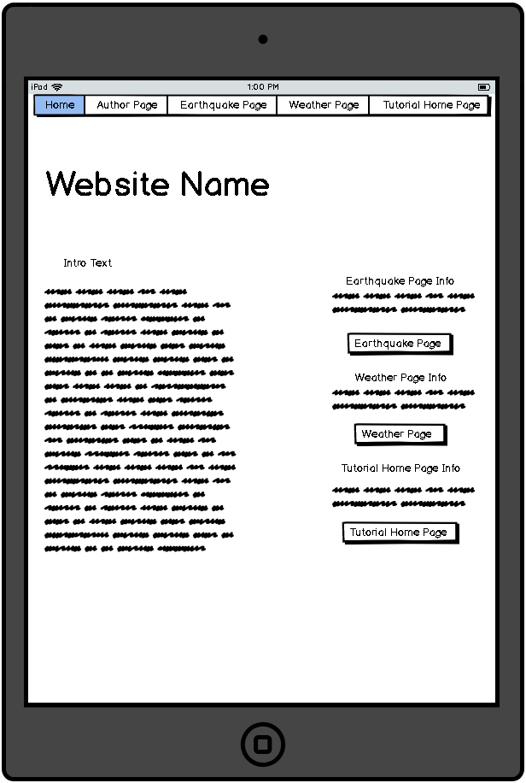

The layout is clean and concise, the page features buttons which will give quick and easy navigational access, the page features basic information about each and every page,

**Desktop:**

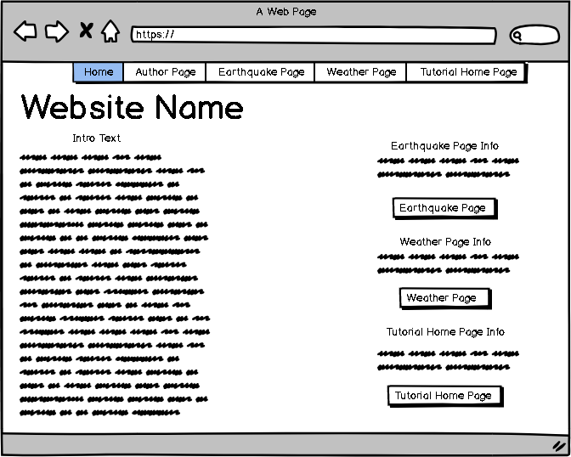

Justify what is good about it, why it works etc.

**Checklist**

|  |  |
| --- | --- |
| **Requirement** | **Complete** |
| Responsive Layout |  |
| Aesthetically attractive |  |
| Consistent design/layout |  |
| Explanation of the project |  |
| Link to the project specification in PDF form |  |
| Suitably serves as the website homepage |  |

# Author Page

Introduce each member and describe their rolls/activities within the project.

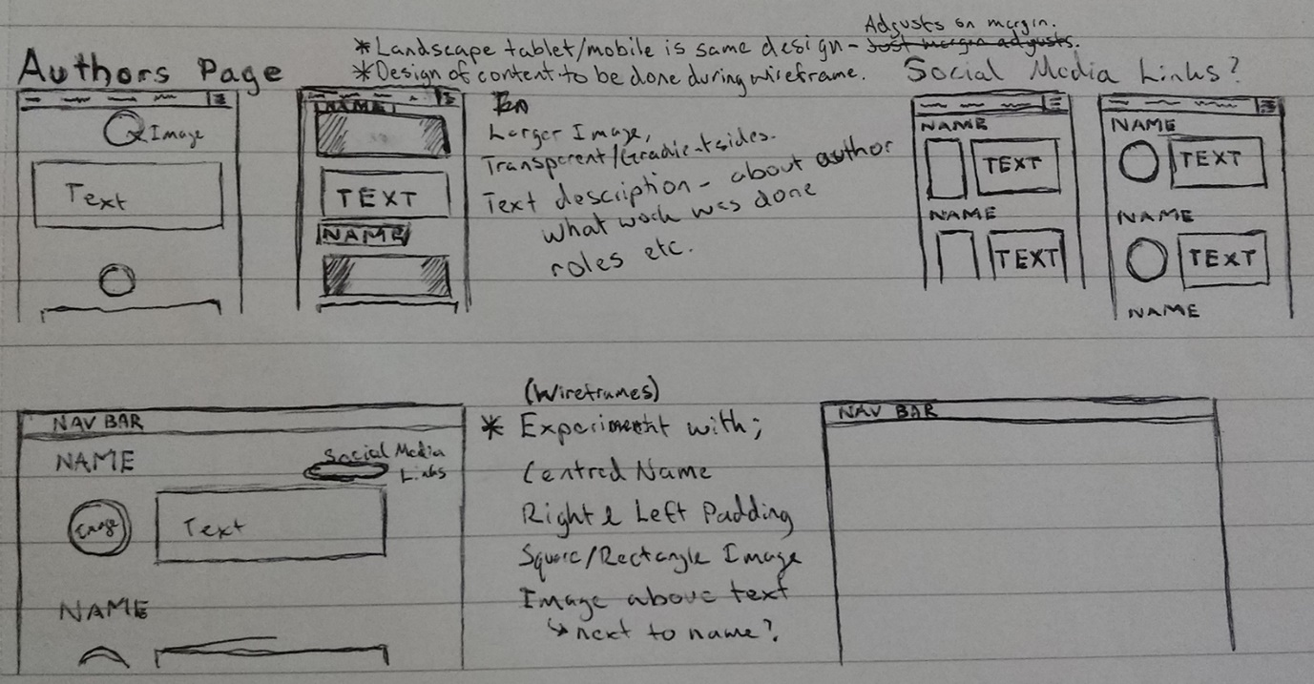

**Requirements:**

Responsive layout

Aesthetically attractive

Consistent design/layout

Introduction to each of the group members

Describes roles/activities of each group member

**Selected Design:**

**Mobile:**

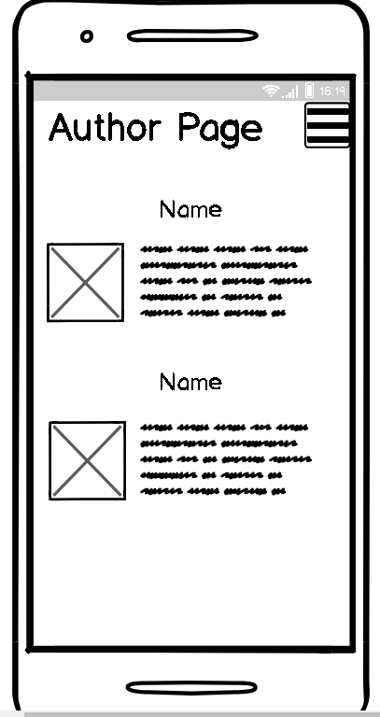

Simple design easy to view and understand hamburger menu is universally used so users will know what it is instantly

**Tablet:**

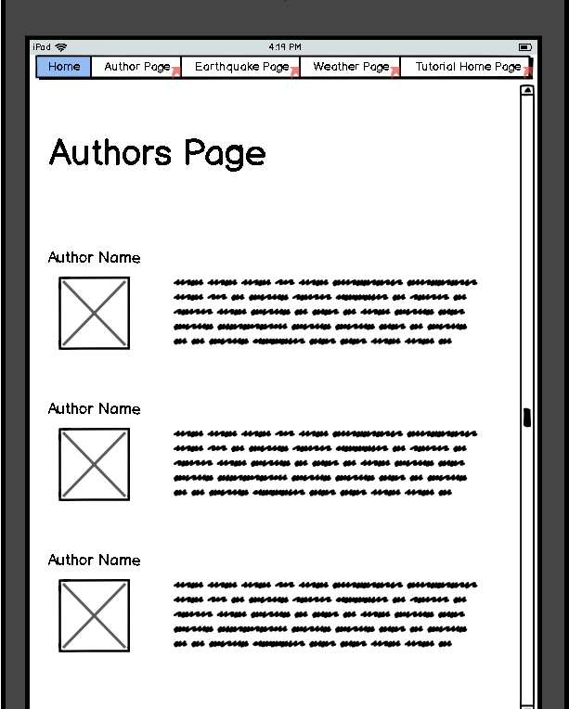

Simple design easy to view and understand makes good use of the bigger screen size of the tablet

**Desktop:**

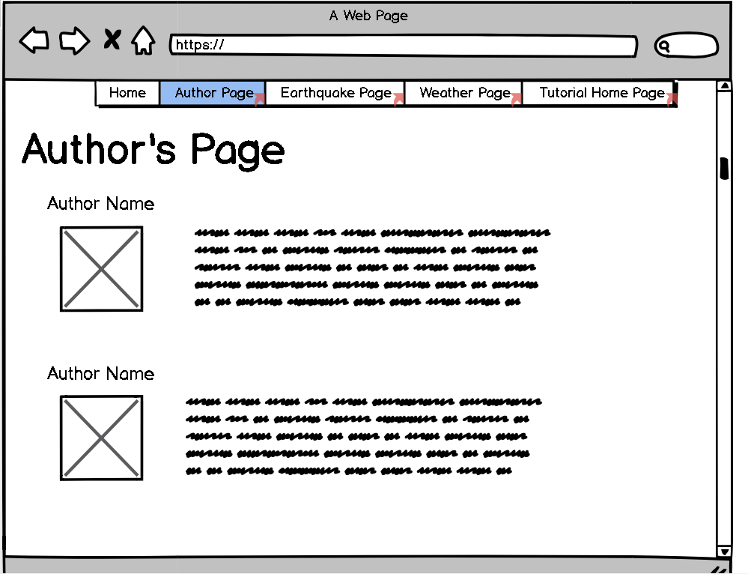

Simple design easy to view and understand makes good use of the bigger screen size of the desktop screen.

**Checklist**

|  |  |
| --- | --- |
| **Requirement** | **Complete** |
| Responsive Layout |  |
| Aesthetically attractive |  |
| Consistent design/layout |  |
| Suitable introduction to each group member |  |
| Description of roles/activities for each group member |  |

# Earthquake Page

Refer to specification

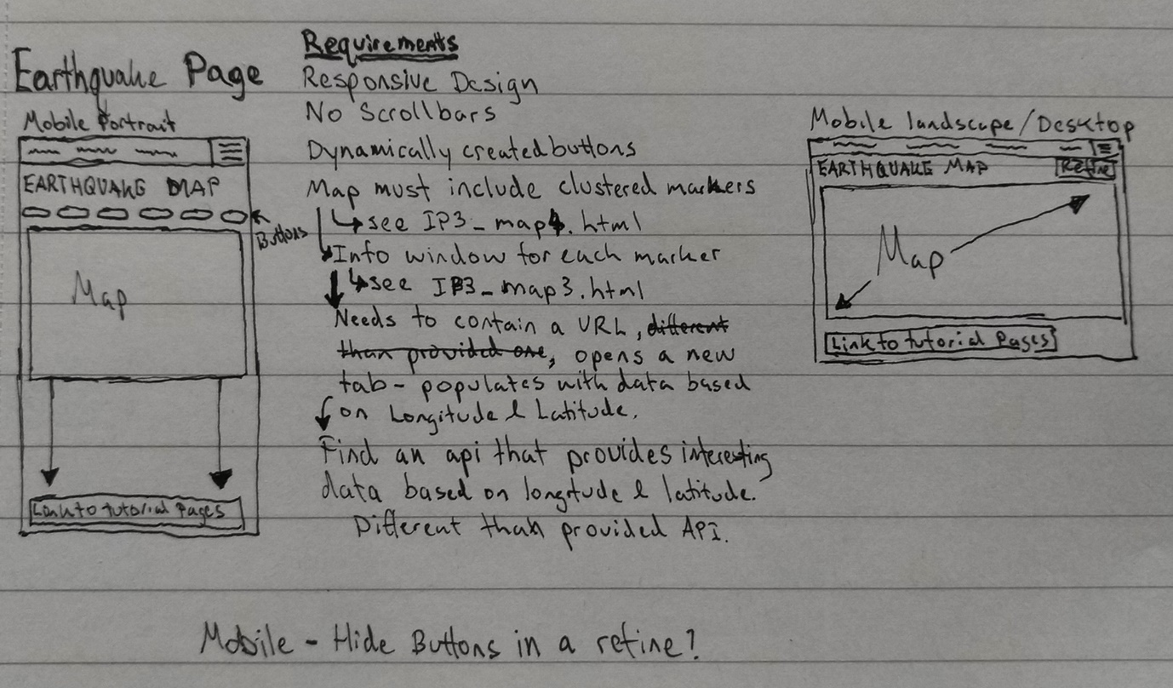

**Requirements:**

Responsive layout

Aesthetically attractive

Consistent design/layout

No scrollbars – resize map based on device properties

Has dynamically created buttons to adjust the displayed data

Map must include clustered markers, each marker has an info window

Info window has a link which opens in a new browser tab. New browser tab is populated with data based on longitude and latitude of parent marker.

**Selected Design:**

**Mobile:**

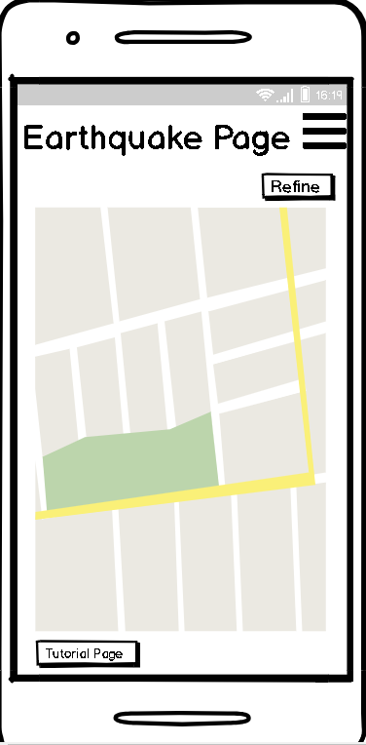

Simple design makes the map easy to use, having a big map makes it easier for users to use and view, simple buttons to open the filters and refined search and a button to instantly access the earthquake tutorial page. Hamburger menu works as an easy to use navigation menu.

**Tablet:**

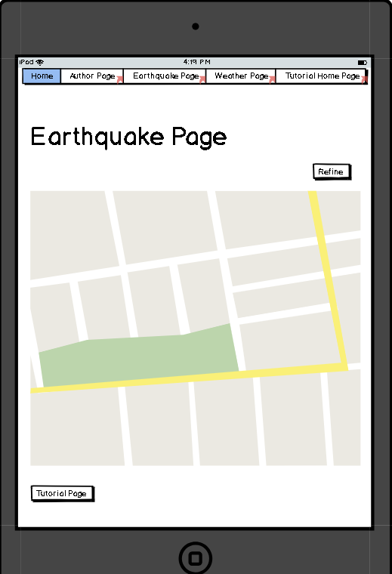

Simple design makes the map easy to use, having a big map makes it easier for users to use and view, simple buttons to open the filters and refined search and a button to instantly access the earthquake tutorial page. Has the navigation bar at the top, makes good use of the screen. Refine search button help users customise their search to exactly what they want.

**Desktop:**

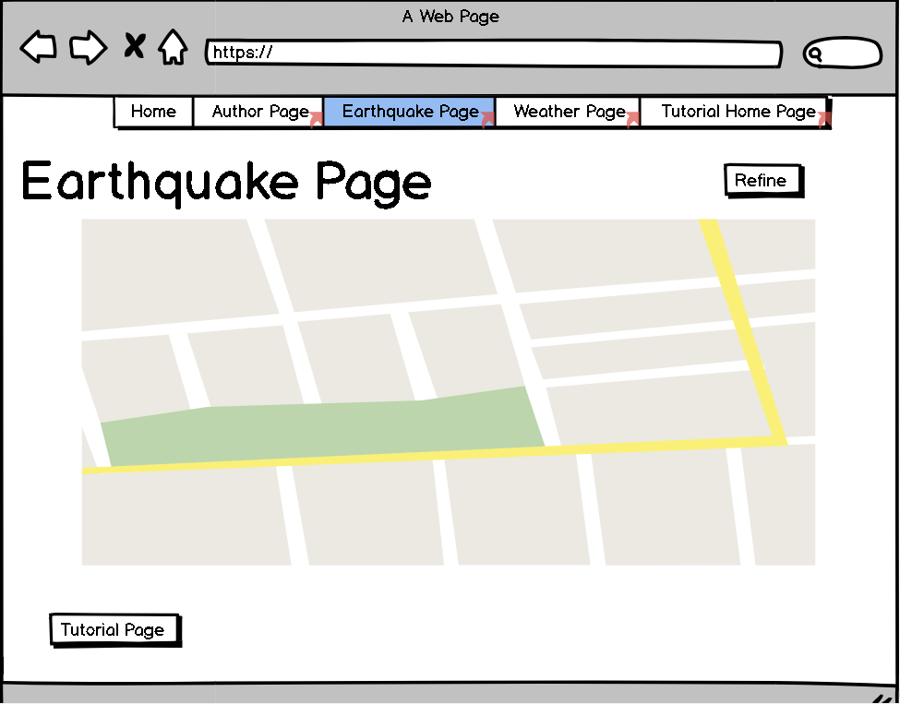

Simple design makes the map easy to use, having a big map makes it easier for users to use and view, simple buttons to open the filters and refined search and a button to instantly access the earthquake tutorial page. Has the navigation bar at the top, makes good use of the screen. Refine search button help users customise their search to exactly what they want.

**Checklist**

|  |  |
| --- | --- |
| **Requirement** | **Complete** |
| Responsive Layout |  |
| Aesthetically attractive |  |
| Consistent design/layout |  |
| No scrollbars |  |
| Has buttons which refines the data being displayed |  |
| Map has clustered markers with info windows |  |
| Info windows have a link which opens in a new tab and displays data based on the parent marker’s longitude and latitude |  |

# Weather page

Refer to specification

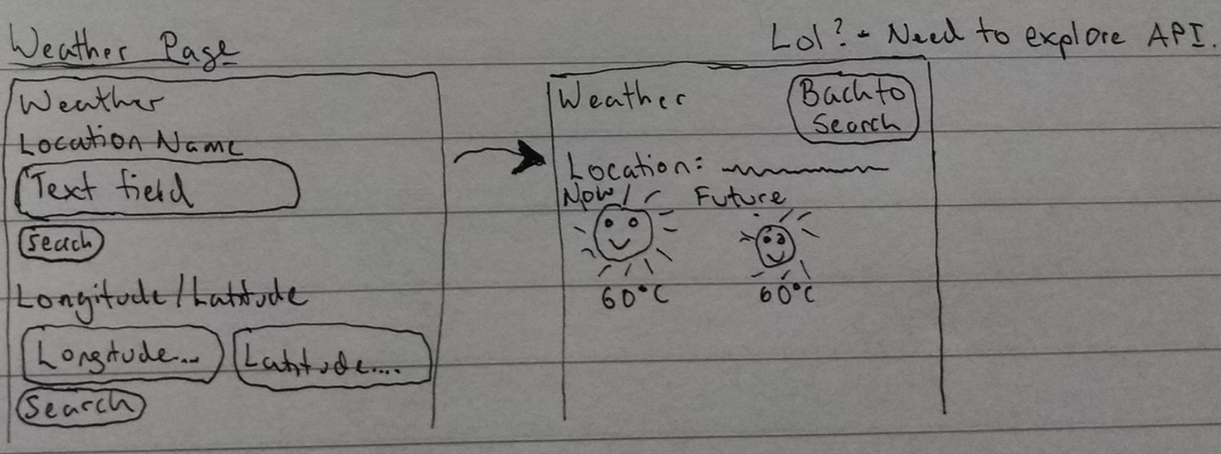

**Requirements:**

Responsive layout

Aesthetically attractive

Consistent design/layout

Specify the location by longitude/latitude or location name

Page displays the requested location current weather and forecast

**Selected Design:**

**Mobile:**

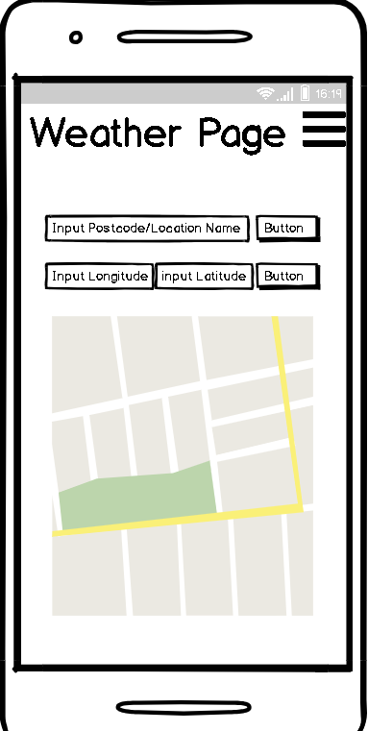

Simple and easy to use. All the search refinements are at the top and easy to use with only a text input and button. Hamburger menu is easy to use and easily recognisable.

**Tablet:**

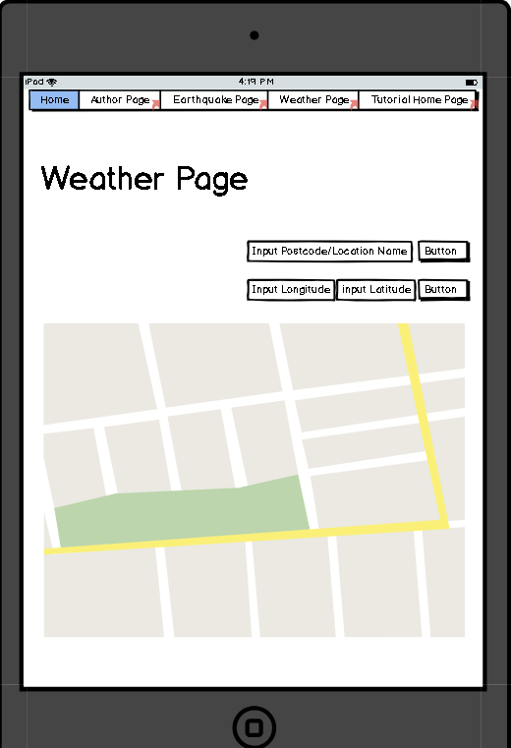

Simple and easy to use. All the search refinements are at the top and easy to use with only a text input and button. Makes good use of the bigger screen.

**Desktop:**

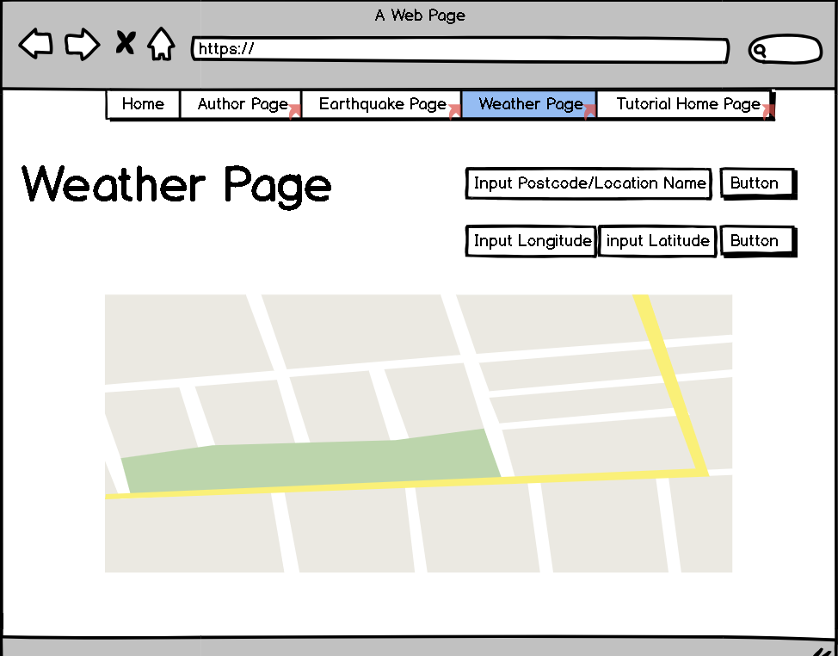

Simple and easy to use. All the search refinements are at the top and easy to use with only a text input and button. Makes good use of the bigger screen.

**Checklist**

|  |  |
| --- | --- |
| **Requirement** | **Complete** |
| Responsive Layout |  |
| Aesthetically attractive |  |
| Consistent design/layout |  |
| Can specify the location by longitude/latitude or location name |  |
| Once location is set, page auto loads the weather data and forecast |  |
| Weather forecast data makes use of weather icons (sunny, rainy etc images) |  |

# Tutorial index page

Contains a list of links to all of the tutorial pages – there’s so many it’s better to have a tutorial main page.

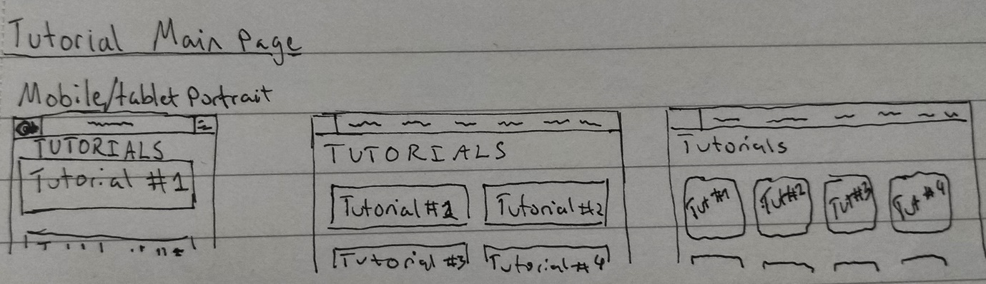

**Requirements:**

Responsive layout

Aesthetically attractive

Consistent design/layout

Contains link to each of the tutorial pages

**Selected Design:**

**Mobile:**

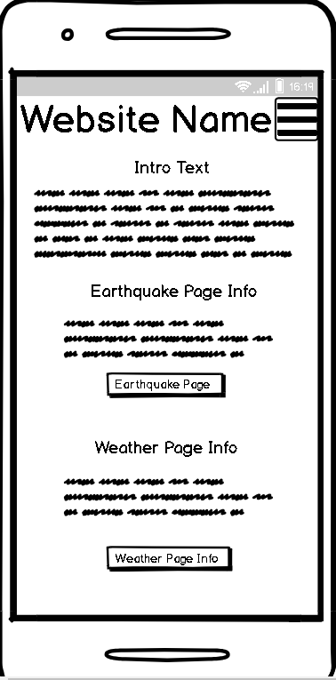

Simple and easy to use. Hamburger menu is easy to use and easily recognisable. All of the tutorials are displayed with information about what they are.

**Tablet:**

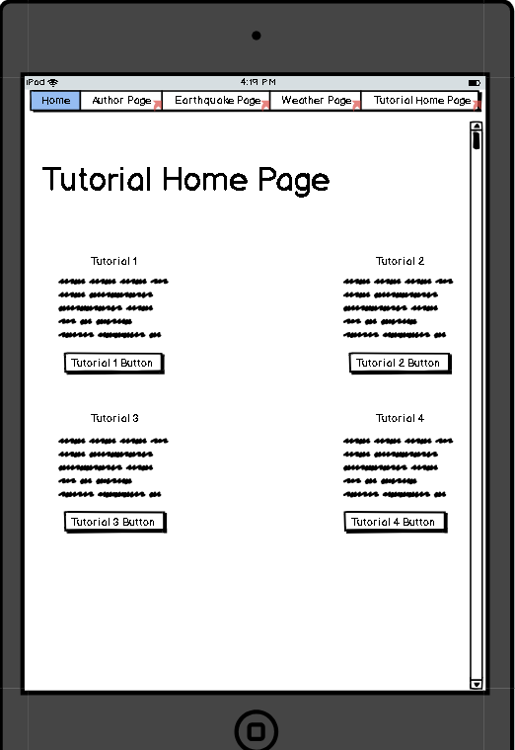

Simple and easy to use. Makes good use of the bigger screen. Tutorials are placed 2 at time due to the bigger screen.

**Desktop:**

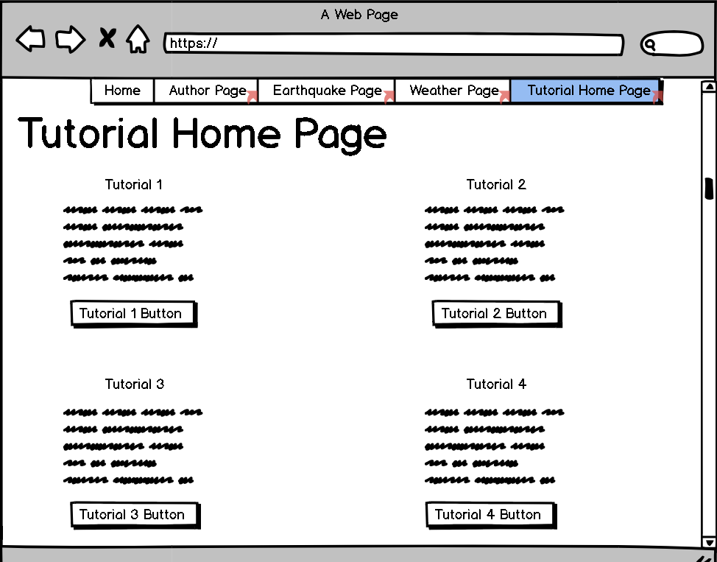

Simple and easy to use. Makes good use of the bigger screen. Tutorials are placed 2 at time due to the bigger screen.

**Checklist**

|  |  |
| --- | --- |
| **Requirement** | **Complete** |
| Responsive Layout |  |
| Aesthetically attractive |  |
| Consistent design/layout |  |

# Standard tutorial page

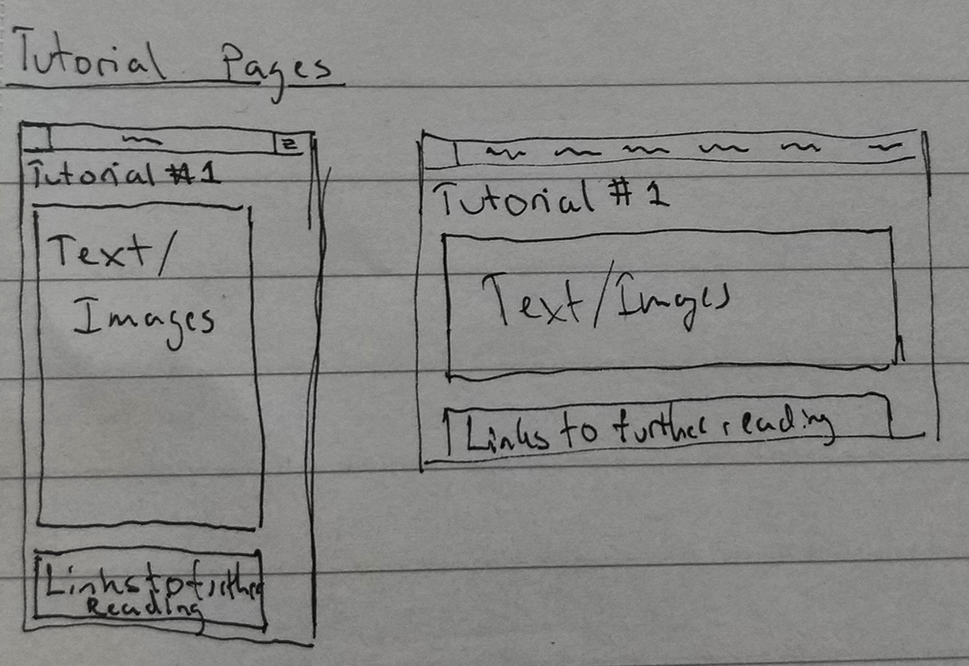

**Requirements:**

Responsive layout

Aesthetically attractive

Consistent design/layout

Provides links to a range of external tutorial pages that provide more detailed information

Introduce GeoJSON so that a reader can gain a basic understanding

Note: Al tutorial pages will follow the same standard layout therefor there will only be one wireframe will be shown as they all follow the same standard.

**Selected Design:**

**Mobile:**

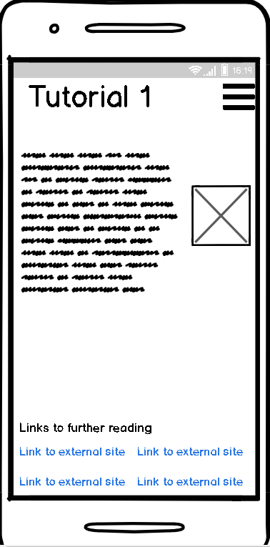

Simple design easy to use having lots of space allows for extra tutorial writing to be added to make sure that users are taught correctly. Having all the external reading links at the bottom keeps them in one place that users can view after reading the tutorial.

**Tablet:**

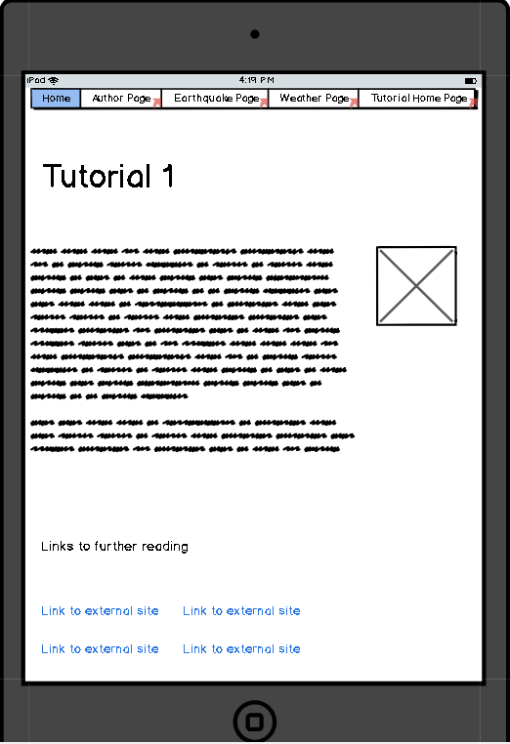

Simple design easy to use having lots of space allows for extra tutorial writing to be added to make sure that users are taught correctly. Having all the external reading links at the bottom keeps them in one place that users can view after reading the tutorial. Makes good use of the bigger screen space.

**Desktop:**

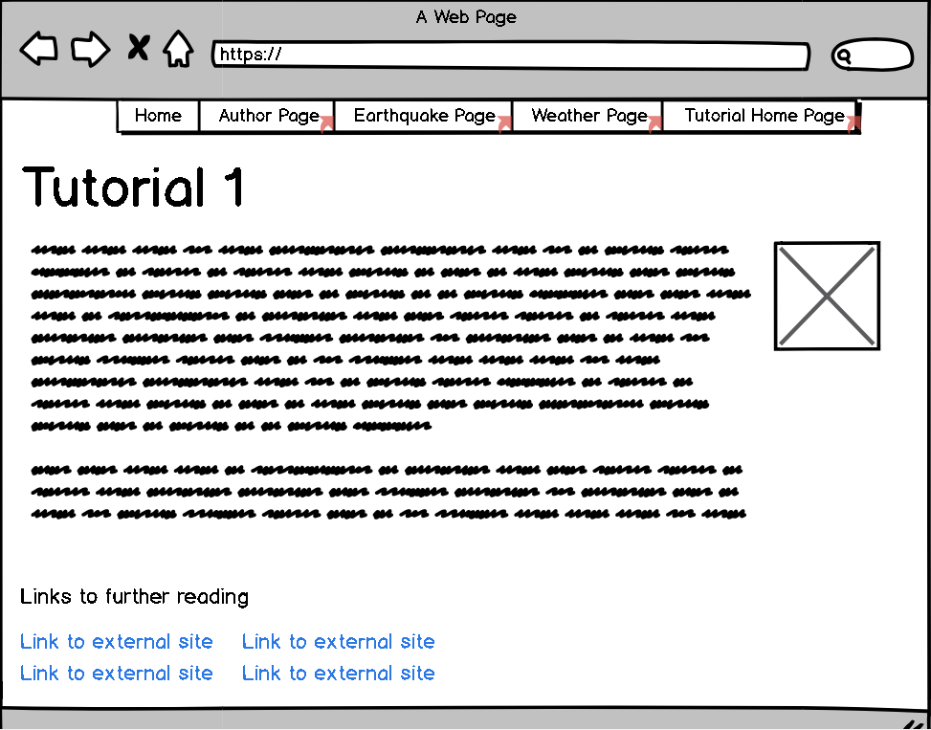

Simple design easy to use having lots of space allows for extra tutorial writing to be added to make sure that users are taught correctly. Having all the external reading links at the bottom keeps them in one place that users can view after reading the tutorial. Makes good use of the bigger screen space.

**Checklist**

|  |  |
| --- | --- |
| **Requirement** | **Complete** |
| Responsive Layout |  |
| Aesthetically attractive |  |
| Consistent design/layout |  |
| Provides an introduction to GeoJSON |  |
| Links provided to a range of external tutorial pages on GeoJSON |  |

# User created visualisation page #1: Shakespeare Word Cloud

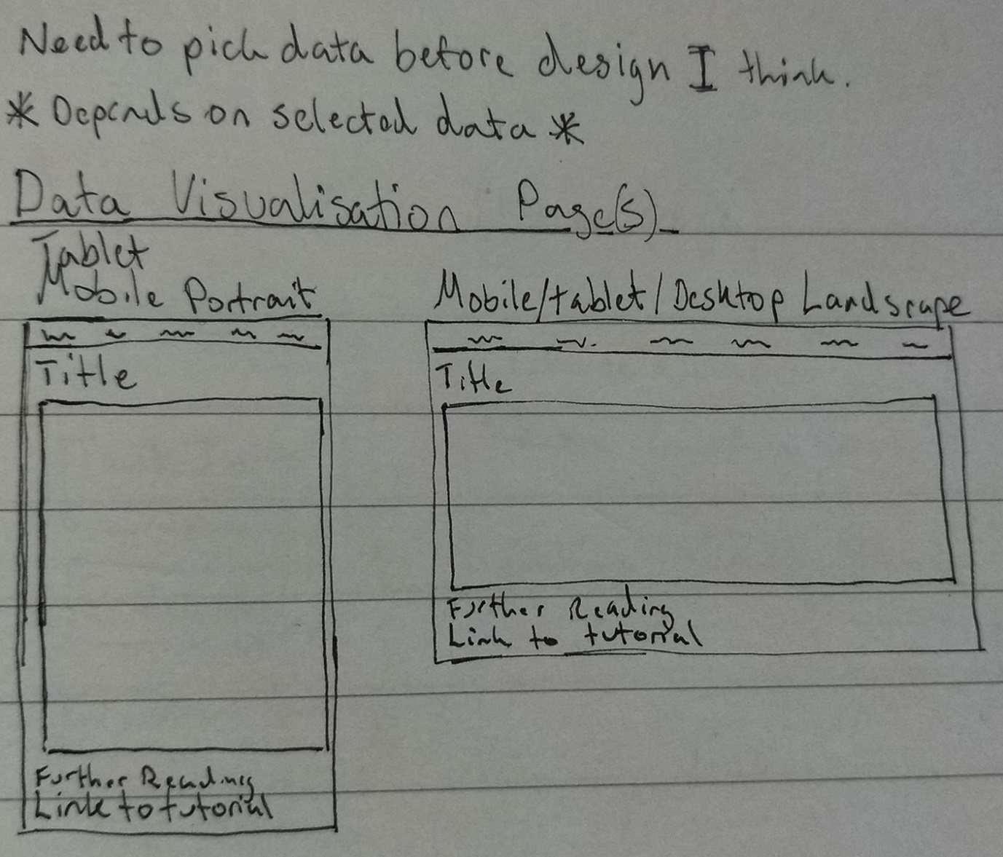

**Requirements:**

Responsive layout

Aesthetically attractive

Consistent design/layout

Contains visualisation of appropriate data

**Selected Design:**

**Mobile:**

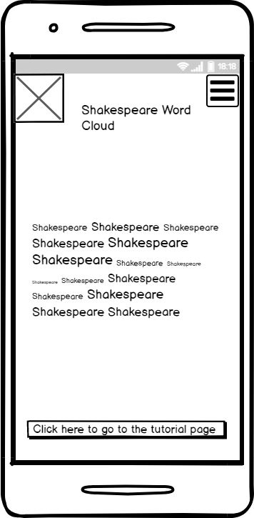

Simple Design the visualization is easy to use and understand has a lot of extra space for more words to be added to the word cloud. Button at the bottom allows users to access the tutorial page for this visualisation which helps accessibility.

**Tablet:**

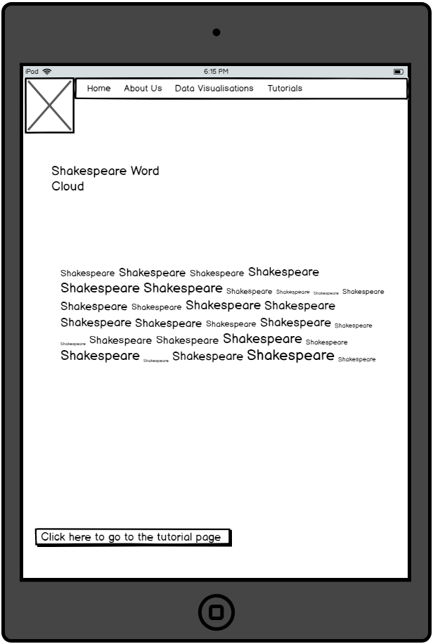

Simple design the visualization is easy to use and understand has a lot of extra space for more words to be added to the word cloud. Button at the bottom allows users to access the tutorial page for this visualisation which helps accessibility.

**Desktop:**

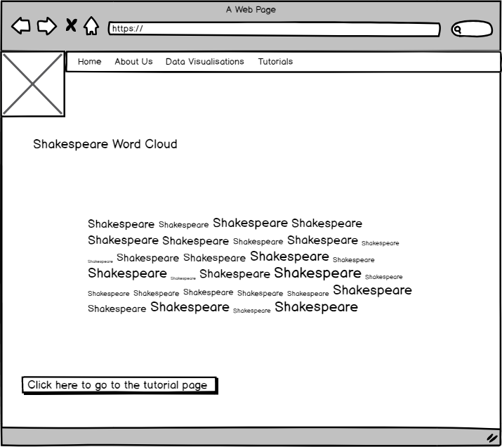

Simple Design the visualization is easy to use and understand has a lot of extra space for more words to be added to the word cloud. Button at the bottom allows users to access the tutorial page for this visualisation which helps accessibility.

**Checklist**

|  |  |
| --- | --- |
| **Requirement** | **Complete** |
| Responsive Layout |  |
| Aesthetically attractive |  |
| Consistent design/layout |  |
| Contains visualisation of appropriate data |  |

# User created visualisation page #2: Hearthstone Page



**Requirements:**

Responsive layout

Aesthetically attractive

Consistent design/layout

Contains visualisation of appropriate data

**Selected Design:**

**Mobile:**

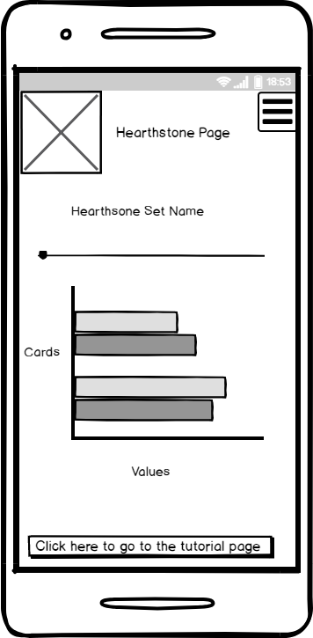

Simple design the data in the visualisation is easy to access and view, the slider makes it easy to navigate through the different sets of cards and the button at the bottom makes navigation easier for those who want to read how the page was made.

**Tablet:**

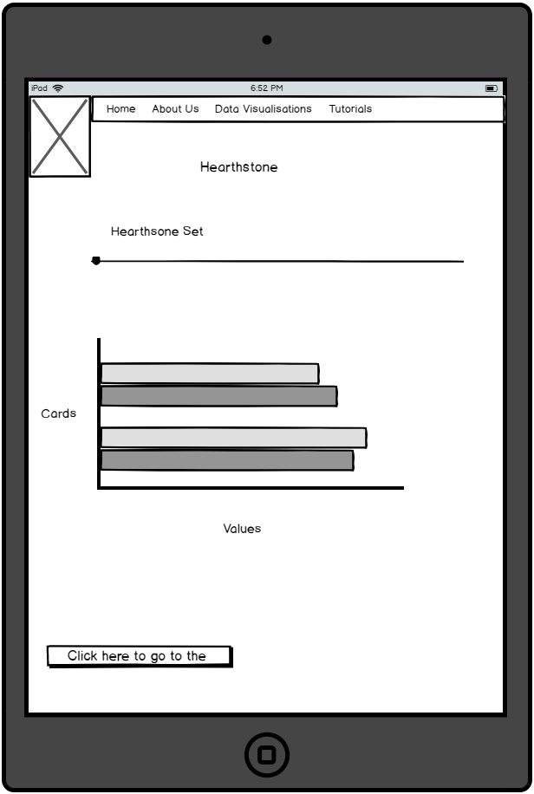

Simple design the data in the visualisation is easy to access and view, the slider makes it easy to navigate through the different sets of cards and the button at the bottom makes navigation easier for those who want to read how the page was made.

**Desktop:**

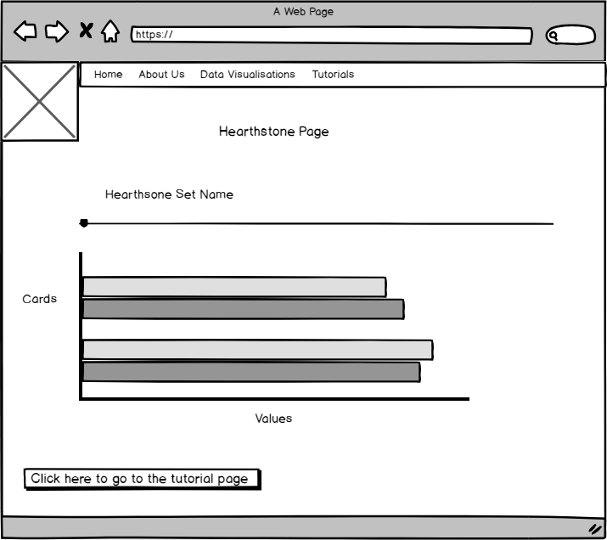

Simple design the data in the visualisation is easy to access and view, the slider makes it easy to navigate through the different sets of cards and the button at the bottom makes navigation easier for those who want to read how the page was made.

**Checklist**

|  |  |
| --- | --- |
| **Requirement** | **Complete** |
| Responsive Layout |  |
| Aesthetically attractive |  |
| Consistent design/layout |  |
| Contains visualisation of appropriate data |  |

# User created visualisation page #3: Movies Visualisation



**Requirements:**

Responsive layout

Aesthetically attractive

Consistent design/layout

Contains visualisation of appropriate data

Note: Since balsamiq’s pie chart options weren’t editable it may be unclear what the wireframe denotes, the pie chart would have many different wedges each featuring a different genre that would be shown as you hover over a particular wedge.

**Selected Design:**

**Mobile:**

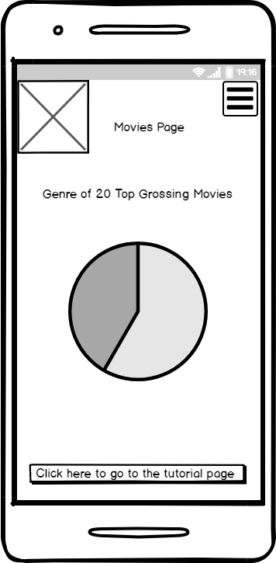

Simple design the data in the visualisation is easy to access and view, the pie chart makes it easy to view the different genres of movies and the button at the bottom makes navigation easier for those who want to read how the page was made.

**Tablet:**

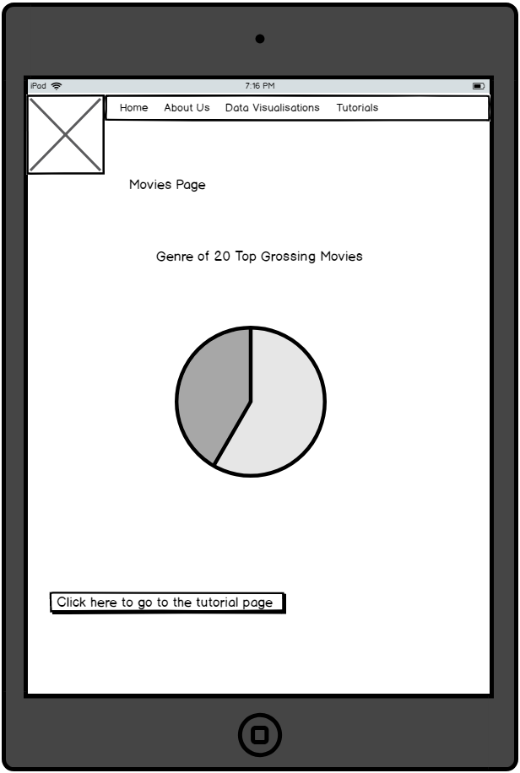

Simple design the data in the visualisation is easy to access and view, the slider makes it easy to navigate through the different sets of cards and the button at the bottom makes navigation easier for those who want to read how the page was made.

**Desktop:**

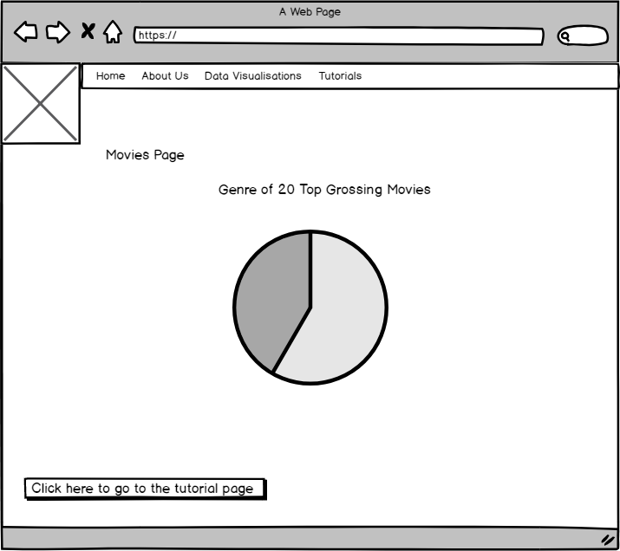

Simple design the data in the visualisation is easy to access and view, the slider makes it easy to navigate through the different sets of cards and the button at the bottom makes navigation easier for those who want to read how the page was made.

**Checklist**

|  |  |
| --- | --- |
| **Requirement** | **Complete** |
| Responsive Layout |  |
| Aesthetically attractive |  |
| Consistent design/layout |  |
| Contains visualisation of appropriate data |  |

# User created visualisation page #4: Music Visualisation



**Requirements:**

Responsive layout

Aesthetically attractive

Consistent design/layout

Contains visualisation of appropriate data

**Selected Design:**

**Mobile:**

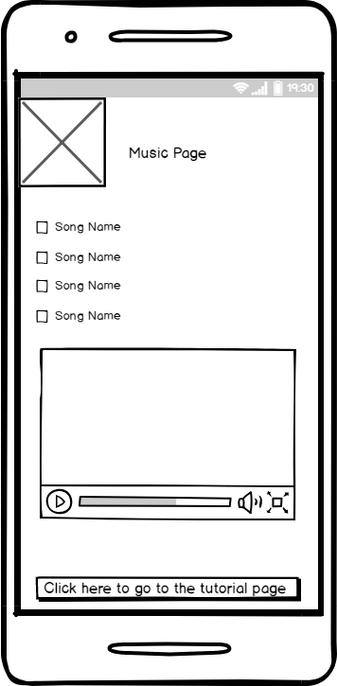

Simple design the data in the visualisation is easy to access and view, the checkboxes make it easy to choose a different song and the video shows that song as bars showing high and low pitch parts of the song, the button at the bottom makes navigation easier for those who want to read how the page was made.

**Tablet:**

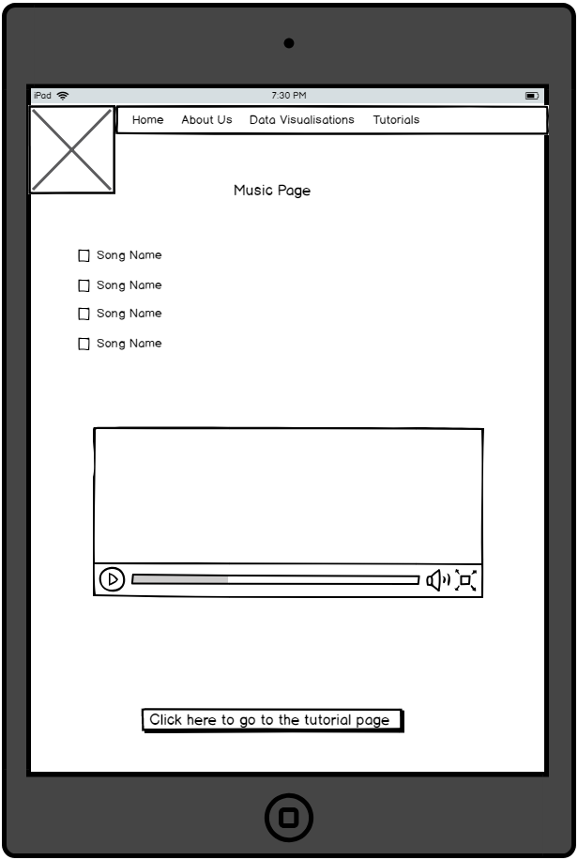

Simple design the data in the visualisation is easy to access and view, the checkboxes make it easy to choose a different song and the video shows that song as bars showing high and low pitch parts of the song, the button at the bottom makes navigation easier for those who want to read how the page was made.

**Desktop:**

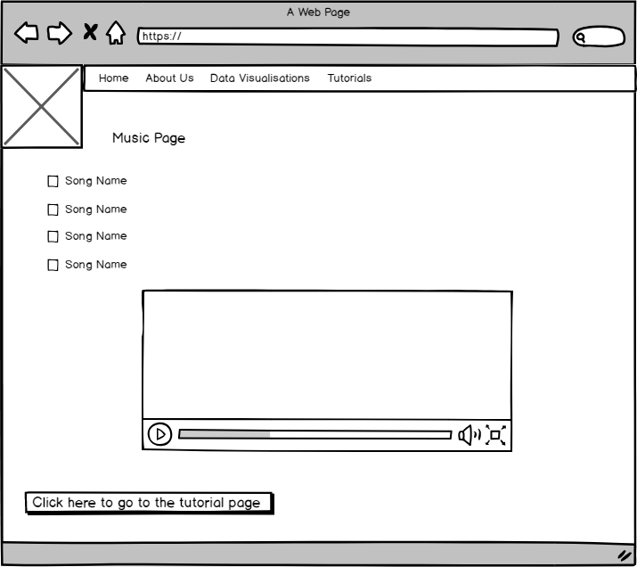

Simple design the data in the visualisation is easy to access and view, the checkboxes make it easy to choose a different song and the video shows that song as bars showing high and low pitch parts of the song, the button at the bottom makes navigation easier for those who want to read how the page was made.

**Checklist**

|  |  |
| --- | --- |
| **Requirement** | **Complete** |
| Responsive Layout |  |
| Aesthetically attractive |  |
| Consistent design/layout |  |
| Contains visualisation of appropriate data |  |